**ChatterTale Prototype Manual Setup**

List of materials:

|  |  |
| --- | --- |
| Male-male dupont cables | 1 Pack |
| Male-female dupont cables | 1 Pack |
| Arduino Uno or mega | 1 |
| Adafruit Musicmaker shield | 1 |
| Push buttons | 5 |
| 250 ohm resistors | 5 |
| Max 9841 microphone | 1 |
| Headphone jack | 1 |
| 12 v battery | 1 |
| 10 k potentiometer | 2 |
| SD card | 1 |
| 3.5 mm Earphone jack | 1 |

Material for the amplifier:

|  |  |
| --- | --- |
| 10 k potentiometer | 1 |
| LM386 | 1 (This is a sensitive component: use caution) |
| 1.2k ½ watt | 1 |
| 10 nano farad ceramic capacitor | 1 (for the bypass) |
| 10 micro farad ceramic capacitor | 1 |
| 10 ohm ½ watt resistor | 1 |
| ≈ 0.05 micro farad ceramic capacitor | 1 |
| 250 micro farad electrolytic capacitor | 1 |

1. Take an Arduino Uno board and a Adafruit Musicmaker MP3 shield and attach them together from the pins as shown. Start by placing the MP3 shield on top of the Arduino board.

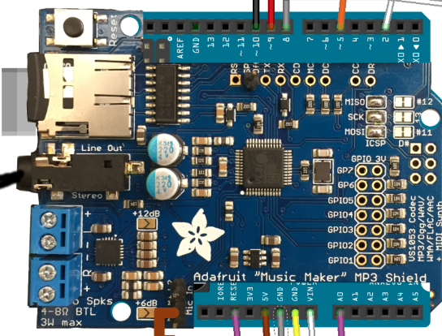

1. Next, apply the push buttons to the breadboard. Take the breadboard and 5 push buttons and 5 male-to-female wires. You will also need 5 250 ohm 0.25 W resistors. Follow the diagram below when assigning the wires and resistors on the breadboard (Note the resistors in the diagram don’t match the resistors we need, diagram is for placement guidance). Connect the wires from the breadboard to the digital pins of the MP3 shield (digital pins # 9,8,5 and 2). The last wire will be pinned to the RESET header on the shield. Pin 2 will be for Pause/Play. Pin 5 will be fast forward/skip forward. Pin 8 will be record. Pin 9 will be rewind/skip backward. And finally the reset pin will restart the device.

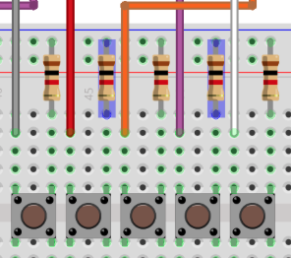 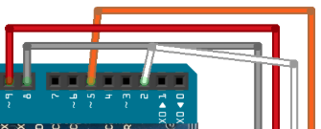**Screen Shot 2015-03-02 at 12.29.43 PM.png**

1. Next, place a potentiometer on the same breadboard where you previously placed the push buttons. The potentiometer is going to serve as a volume dial. If it doesn't already have 3 wires soldered to it, do so. With the dial facing towards you, take the leftmost wire and pin it to the plus column in your breadboard. Then take the rightmost wire and pin it to the minus column on your breadboard. Now with the middle wire, pin it directly to the breadboard and take a male to female wire and pin it to the breadboard next to the middle wire you pinned from the potentiometer and pin it to the MP3 shield on Analog 0 “A0”.

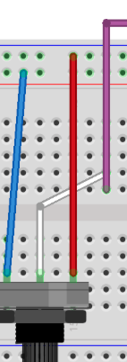Screen Shot 2015-03-02 at 12.48.13 PM.png

1. Place a LED light indicator onto the breadboard. Looking at the LED's pin ends, there should be one long end and one short end. Taking the short end, place it into the minus column of your breadboard, then proceed to placing the long end pin on your breadboard. Next take a resistor as well as another male to female wire and follow the diagram to place the resistor and the wire so that they are aligned with the LED light placed on the breadboard. The other end of the wire should be pinned to Digital pin 10 on the surface of the MP3 shield.

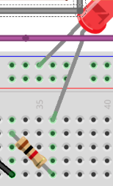 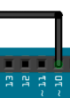

1. Next take microphone component along with 1 male-to-female wire and 2 male-to-male wires. Follow the diagram below: with the “Out” pin wire a male-to-female wire that from the breadboard to the surface of the music shield to the M+ pin. With the next pin on the microphone, “VDD” take a male-to-male wire and connect the “VDD” pin to the minus column on the breadboard. Finally, use a male-to-male wire to connect the “GND” pin on the microphone wire with the plus column on the breadboard.

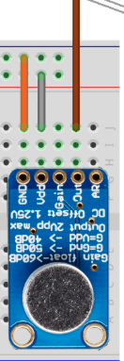 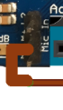

1. Using 2 male-to-female wires connect one on the plus column from the breadboard to the “5V” pin on surface of the MP3 shield. The second wire will be connected from the minus column of the breadboard to the “GND” pin on the surface of the MP3 shield as detailed below

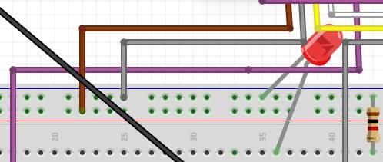 **Screen Shot 2015-03-02 at 1.16.47 PM.png**

1. The next step is to setup the audio switchboard. Connect the “GND” pin on the MP3 shield with the minus column of your second breadboard. Using a second wire, connect the MP3 shield pin “Vin” and the plus column of the new breadboard.

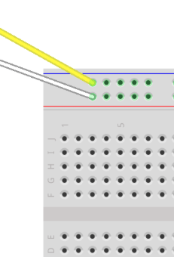 Screen Shot 2015-03-02 at 1.18.58 PM.png

1. Next, using two male-to-male wires connect the two sides of the breadboard: plus to plus and minus to minus as shown.

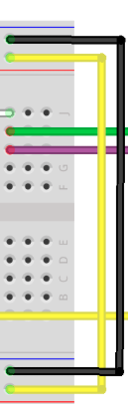

1. The next step is to install the audio amplifier. This is chip labeled “LM386” and is very sensitive to electrostatic discharge. It is recommended to use Before placing it onto the breadboard take a look to see if there is a groove on the amplifier. Use this notch to orientate the chip so that the notch is on the left side of the amplifier. Use the diagram as a guide for placement.

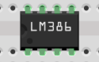

1. Take a 1.2K ohm resistor and using the diagram as reference, take one end of the pin and place it next to the far bottom left pin of the amplifier. Then take a 10uF (micro farads) capacitor that is 25V and place the pin end that doesn’t have white shaded on the capacitor and place it next to the top far left pin of your amplifier. All that is left is to place the other end pin of the resistor and the capacitor next to each other as shown on the diagram.

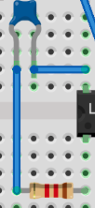

1. Connect a 100nF (nano farad) capacitor to pin 7 of the amplifier as well as to ground (the minus column of the breadboard).

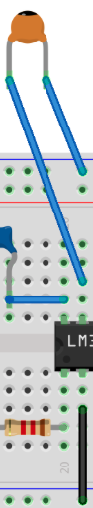

Connect pin number 6 of the amplifier to the plus column of the breadboard with a male-to-male wire.

1. Next, with the potentiometer in hand, and with the dial facing towards you take the left wire and place it in the minus column of your breadboard.
2. Pin the middle wire of the potentiometer to pin 3 of the amplifier.
3. The headphone jack has 5 leads, 1 in the front and 4 in the back. Connect the back 4 leads to the breadboard to 4 different terminal strips with the headphone jack facing away from you.
4. Connect the headphone aux cable by taking the green and purple wires and pining them aligned to the far left wire of the headphone jack. Then with the yellow wire from the headphone aux cord, pin it next to the far right wire of the headphone jack.
5. Back to the potentiometer. Connect the mid-left wire of the headphone jack to the far right terminal of the potentiometer.
6. Plug the headphone aux cable into the headphone jack on the Musicmaker shield.

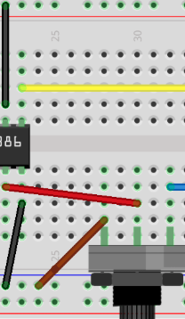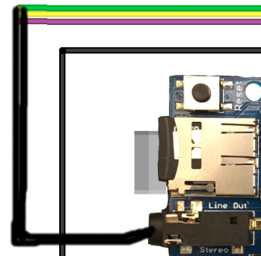

(Note: Green is right output, Yellow is left output and Purple is GND)

1. Connect pin 4 of the amplifier to the minus column of the breadboard.
2. Next we need to take our 250uF capacitor next to the top far right pin of the amplifier. Be sure that the pin is the one on the white shaded side of the capacitor. Then with the other pin place it into the breadboard.
3. We then need to take our speaker and look for the minus polarity wire from our speaker and pin it in front of the capacitor we had just placed. (The pin that isn’t next to the amplifier.) Going back to the speaker, place the other pin into the minus column of our breadboard.
4. Next taking our resistor place one end of the pin behind the capacitor we had just placed and the other endpin to the right of it.
5. Next we need to take are last 2 1uF capacitors and place them behind the right pin of our resistor we just placed. Be sure that the resistors are aligned in a diagonally parallel pacement and that the white shaded sides of the capacitors are facing to the left. (Refer to the diagram)
6. Finally we must place a male to male wire next to our 2 capacitors and pin the other end to the minus column of the bread board.

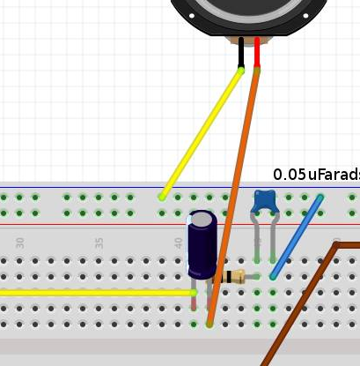

1. Now that we have our setup for testing, it’s time to format our Arduino component. To start you will need a micro SD card. Load into the SD card some music or audio files. Be sure that they are in MP3 format (Ex. Music.mp3) IMPORTANT. The file name must be less than or equal to 8 characters or the device won’t play the files (Ex. abcdefgh.mp3). If need be, rename the files using a computer before uploading them onto the SD card.
2. The SD card must be in the FAT16 or FAT32 format.
3. Add the file v44k1q05.img to the SD card. This file is an important patch to enable recording on the device. The file can be downloaded from the following website: <https://github.com/adafruit/Adafruit_VS1053_Library/blob/master/examples/record_ogg/v44k1q05.img>
4. Place the card into the SD slot on the surface of the MP3 shield.
5. Next we need to upload our program into the Arduino board. The Arduino programing environment can be found at: <http://arduino.cc/en/Main/Software>.
6. Once downloaded and installed, connect the Arduino directly to the computer via a C2G USB cable. Once connected, go back to your Arduino development environment and in the overhead toolbar select “Tools” and then select “Board”. Choose either the “Uno” or “Mega” option.
7. Under the Tools option, select “Serial Port” and select “USB modem”.
8. If this is the first time this computer has been connected to the Arduino, the upload will likely fail. This is probably because the computer doesn’t recognize the Arduino. To resolve this, open Device Manager (for Windows 7, Vista, and XP) and you will find something like the image below: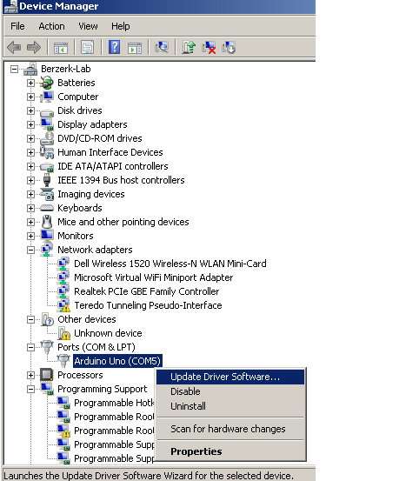

Then to install the drivers, direct Device Manager to the “arduino.inf” file in the Arduino development environment's “Drivers” folder and proceed.

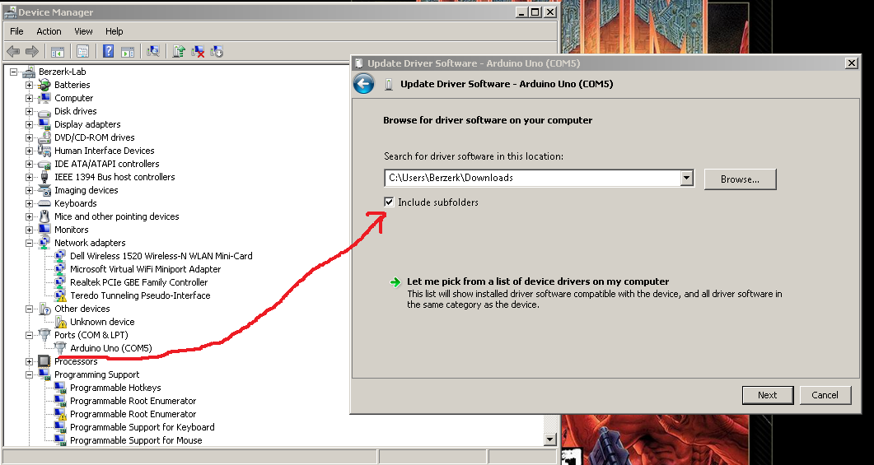

1. Another “first-run” problem involves missing required libraries. These libraries can be found at: <https://github.com/rao102/AudioProject/tree/master/libraries>. Download the ZIP file and extract it to C:\Users\yourUserName\Documents\Arduino\libraries\ depending on your file structure, operating system and Arduino development environment installation.
2. Reopen the Arduino development environment and download the program from <https://raw.githubusercontent.com/rao102/Audio-Project/master/150218_final_uno.ino>
3. Copy and paste the code into the Arduino development environment, being sure to copy all the code.
4. Upload the program to the Arduino by clicking the Upload arrow in the Arduino development environment and wait for prompt indicating that the upload is complete. If there are no errors, you should see something similar to the following screens:

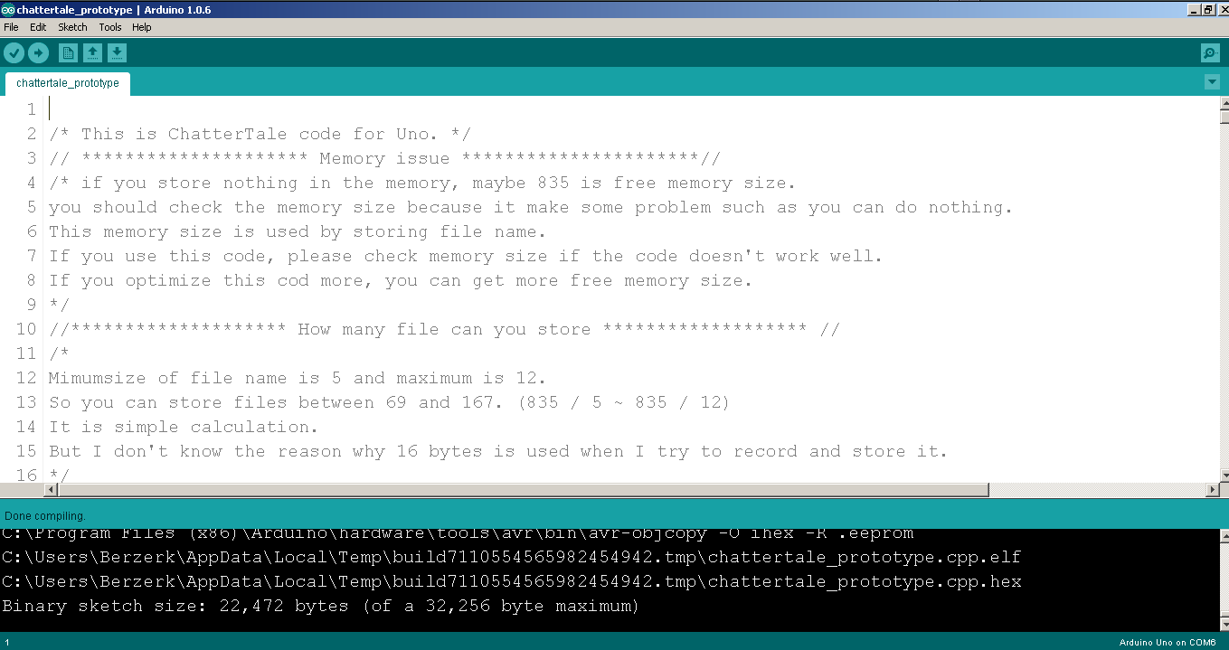

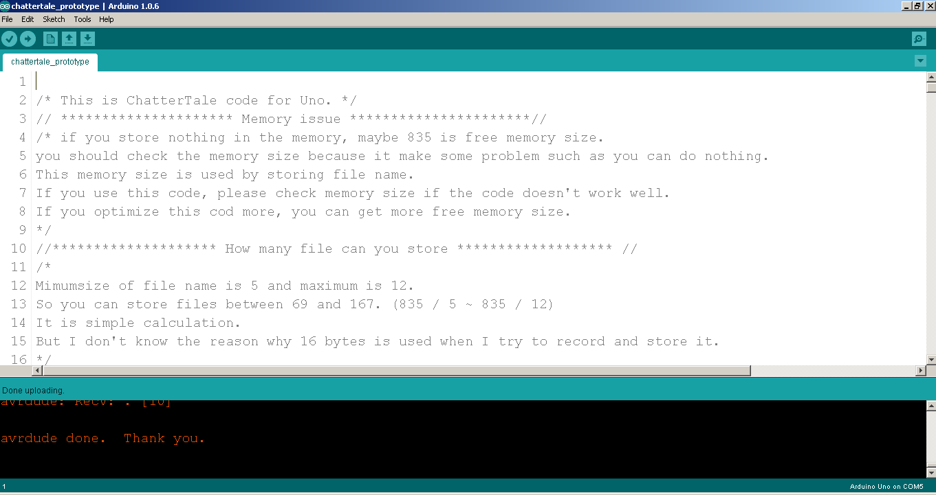

1. Finally, power needs to be supplied. For the ChatterTale, there are actually two input power outputs: One that will be used for power the buttons and the Arduino and the other power output will go directly into the audio switch board (should be at least 12V DC). A 12V DC rechargeable battery that has a output cord and an input cord is preferred but a 12 volt charger can work as well.
2. Attach the 12V 9V DC power Y Splitter Cable (one male head output cord cut off with 2 jumper wires soldered to it).
3. Plug the Y cable into the battery, and proceed to pin the plus and minus polarities of the two jumper wires into the audio switch breadboard's plus and minus columns respectively.
4. Plug the other Y male cord into the Arduino and press the power switch on the battery.
5. Test the buttons and have fun!

If you need to view a full diagram for this setup follow the link below:

<https://raw.githubusercontent.com/rao102/Audio-Project/master/resources/chattertale_bb.png>

Block Diagram

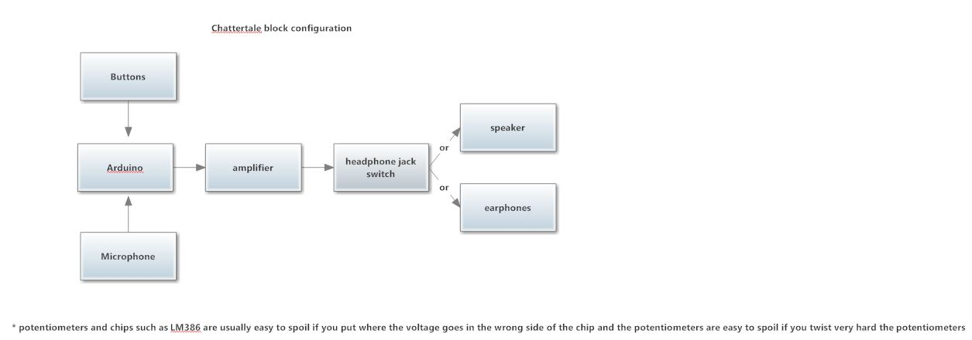

Troubleshooting

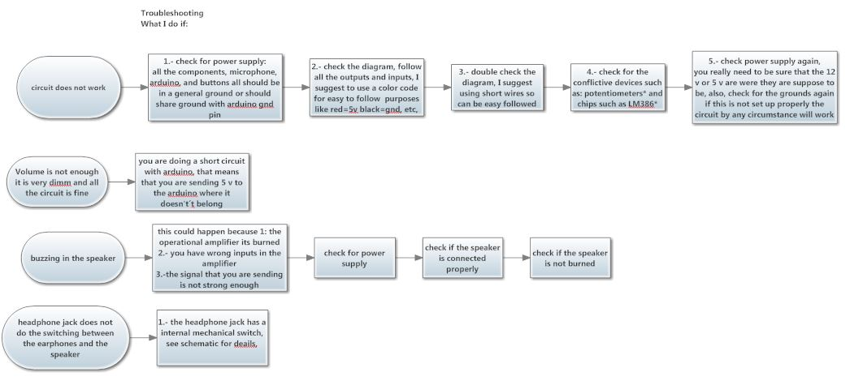

LM386 Pin Layout

